

Express Medical

Payroll Management System

System Requirements Specification

**Authors:**

**Nicholas Borghese**

**Vincent Ippolito**

**Carl Mendez**

**Ilya Shvabskiy**

**Nick Wilson**

**09/28/18**

**TABLE OF CONTENTS**

1.0 Introduction.................................................................................................... 2  
 1.1 Definitions.......................................................................................... 2

1.2 Purpose................................................................................................ 3

1.3 Scope..................................................................................................... 3

1.4 Overview.............................................................................................. 4

2.0 Overall Description…................................................................................... 4

2.1 Product Functions............................................................................ 4

2.2 Product Perspective System interfaces.................................... 5

2.3 User Characteristics........................................................................ 6

2.4 Constraints......................................................................................... 6

2.5 Assumptions and Dependencies.................................................. 7

2.6 Apportioning of Requirements.................................................... 7  
3.0 Specific Requirements.................................................................................7  
 3.1 External Interfaces/Functions..................................................... 7

3.2 Logical Database Requirements................................................... 9  
4.0 Appendices………………................................................................................... 10

**1.0 Introduction**

**1.1 Definitions**

1. **Administrator:** the boss, this is the person requesting us for this software.
2. **Backend:**  denoting a subordinate processor or program, not directly accessed by the user, which performs a specialized function on behalf of a main processor or software system
3. **Cryptographic Hash Function**:​ a hash function which takes an input and returns a fixed-size alphanumeric string; we will be referring to this as a hash function.
4. **Deduction:** amounts which can be taken from an employee's paycheck, like retirement benefits, health care costs, or special funds and donations.
5. **Employee:** An individual who works part-time or full-time under a contract of employment, whether oral or written, express or implied, and has recognized rights and dutie
6. **Frontend:** directly accessed by the user and allowing access to further devices, programs, or databases.
7. **Full Stack**:​ A product that includes both backend and frontend.
8. **Hash**:​ The output of a cryptographic hash function.
9. **HR:** “Human Resources”, the people who make up the workforce of an organization, business sector, or economy.
10. **HTML5**:​ “Hypertext Markup Language”, the latest version to code/create a website.
11. **Interface**:​ What you see on your screen.
12. **IT:** “Information Technologist”, has knowledge of computers, technology, databases and security, and makes sure the computers are able to store, retrieve, transmit, and manipulate data, or information.
13. **JS**:​ “JavaScript” is a backend and is designed for web development.
14. **Pay stub:** a document an employee receives either as a notice that the direct deposit transaction has gone through, or is attached to the paycheck.
15. **PHP**:​ “Hypertext Preprocessor” is a backend and is designed for web development.
16. **Preimage Resistant**:​ A hash function that is difficult to decrypt.
17. **Second Preimage Resistant**:​ A concept where no two different inputs can have the same hash.
18. **Web application:**  A client–server computer program which the client runs in a web browser; essentially, it’s a website

**1.2 Purpose**

This web application is designed to be a payroll management system. It will calculate employee paychecks and deductions. The goal of this web application is to give employees access to their pay stubs, allow administrators and HR representatives to view and modify employees.

**1.3 Scope**

Our payroll management system is a full stack web application that will be developed using HTML , CSS, JS, and PHP for front-end and SQL, JS, and PHP for back-end. The goal of our web-application is to give employees access to their information and pay stubs and to give administrators and HR-reps the ability to add, edit, or delete employee records. In our software, certain access is granted to based on what you are classified as: administrator, HR-rep, or employee.

**1.4 Overview**

Progressing into the document, we provide:

* Overall Description
* Specific Requirements

**2.0 Overall Description**

Continuing in this section, we will be explaining the functions in our web application.

**2.1 Product Functions**

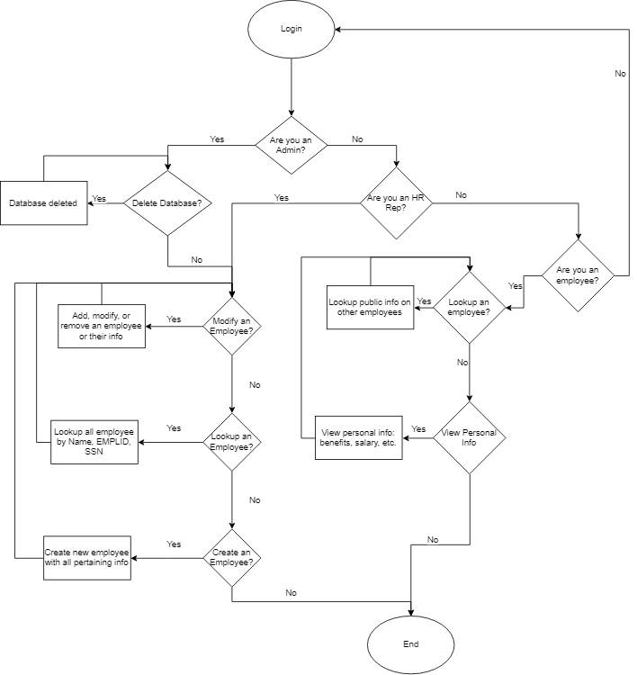

**From our flowchart, we see the permissions for functions are as follows:**

* Admin
  + modify an employee
  + lookup an employee
  + create an employee
  + delete an employee

* HR
  + modify an employee
  + lookup an employee
  + create an employee
* Employee
  + view their personal information

**2.2 Product Perspective System interfaces**

1. ***Login Page*** To use the software, a user must enter a valid username and password. Upon hitting submit, the system will check the information entered by the user. If it is correct it will show the main page. Otherwise, the software will show an error message and request the user to try logging in again. For security purposes, the password will be hashed in our database.
2. ***Successful Login Page* /Home Page** Based on the person’s type, the privileges on the homepage will look slightly different.
3. ***My Info Page*** All of the user’s information (public and private) is displayed here.
4. ***Benefits Page*** This page will display all the user’s benefits with how much they get for each listed one.
5. ***Finances Page*** This page will display the taxes (name and amount) and benefits (name and amount) taken out of the user’s pay as well as allow the user to print this information
6. ***Add Employee*** Only admins and HR-reps have access to this page. Here new employees can be added to the database.
7. ***Edit Employee*** Only admins and HR-reps have access to this page. Here employees already in the database can have their personal information changed.
8. ***Delete Employee*** Only admins and HR-reps have access to this page. Here new employees can deleted from the database.
9. ***Edit Benefits***

Only admins and HR-reps have access to this page. Here employees already in the database can have their benefit information changed.

1. ***Contact*** On this page, any user can search for other employees and see information on how to contact the searched employee.

**2.3 User Characteristics**

This web application was made to be easily understood. It was made to be simple so that anyone with basic computer knowledge could use it.

**2.4 Constraints**

Time is our main constraint. Due to the deadline we were given to create our product, we have limited it to be able to perform basic tasks.

**2.5 Assumptions and Dependencies**

This product is connected to a server. If the server goes down or can’t be accessed then no data can be retrieved or edited.

**2.6 Apportioning of Requirements**

In later versions of this product, you can expect to see:

* A type of user called IT that will be able to manage passwords
  + View and change passwords
* Ability to click on a user in the Contact page and be brought to a page dedicated to them
* Better Front-end design

**3.0 Specific Requirements**

**3.1 External Interfaces/Functions**

After logging in, the user will be directed to the homepage. There, a navigation bar can be seen on the left side as the user goes through every page. Depending on what type of user logs in, different options will be available on the navigation bar.

1. ***Login Page***

The user at this point must enter their username and password. Doing this secures our system in the sense that no unauthorized user gets in. If the user fails to provide valid information, an error message will be displayed asking them to login again. If the information is valid, the user will proceed into our software.

1. ***Home Page***

For all users, this is where the company or medical news will be displayed.

1. ***My Info Page***

This page will display all of the user’s private and public information. It will display the user’s first and last names, date of birth, address, phone number, email address, the last four digits of their social security number, and their position in the company.

1. ***Benefits Page***

This page will display all the benefits the user is entitled to. It will display which healthcare plans they have enlisted in and what life insurance policy they have chosen. It will also display the percentage of their pay they have chosen to put into their 401k.

1. ***Taxes Page***

This page will display all the taxes taken out of the users pay including: state, federal, and city tax.

1. ***Add Employee Page***

This page will allow an admin or HR-rep to add new employees to the database after filling out all the required fields: first name, last name, date of birth, email, address, city, state, zip, password, password confirmation, social security number, social security number confirmation, position in the company, and phone number.

1. ***Edit Employee Page***

This page will display a search bar used to find a specific employee. If they are found in the database, any of their information can be changed..

1. ***Delete Employee Page***

This page will display a search bar used to find a specific employee. If they are found in the database, the can be removed from it.

1. ***Contact Page***

This page will display a search bar used to find a specific employee. If they are found in the database, their name, position, email, phone number, and employee ID are displayed.

**3.2 Logical Database Requirements**

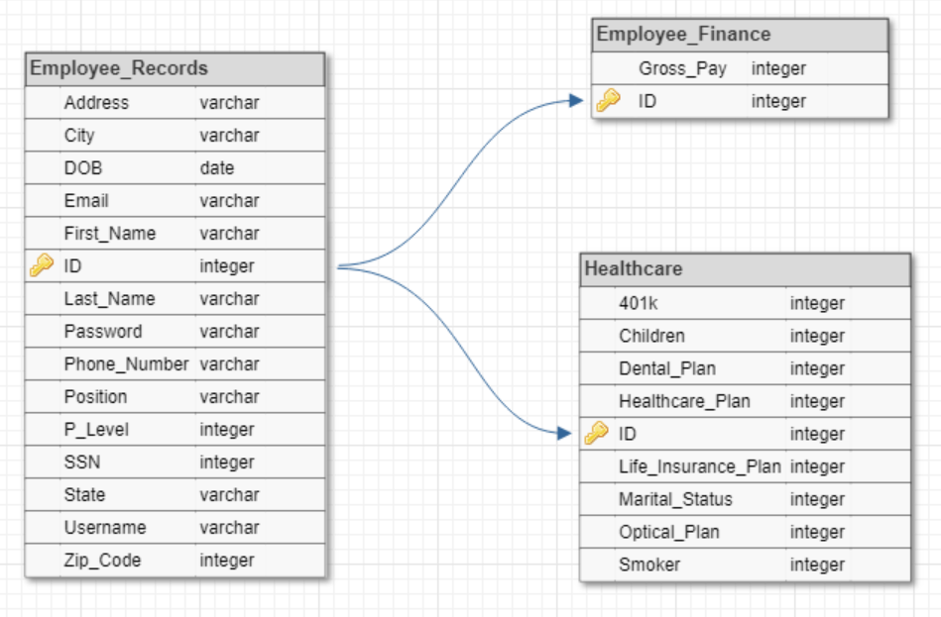

The database for our payroll management system consists of 3 tables, which are: Employee_Records, Employee_Finance, and Healthcare.

* Our main table is Employee_Records, which holds all of an employee’s information. The attributes are ID -- the primary key that auto increments, address, city, DOB, Email, First_Name, Last_Name, Password, Phone_Number, Position, P_Level, SSN, State, Username, Zip_Code.
  + The passwords are stored in the database using the bcrypt algorithm (this constant will be changed over time as stronger PHP algorithms are added)
* Employee_Finance stores information about the employee’s pay and contains a foreign key that connects it to the Employee_Records table. The attributes are ID --the primary and foreign key, Gross_Pay
* Healthcare stores information about the employee that is used to calculate the taxes being deducted from their paycheck. Like Employee_Finance, it contains a foreign key that connects it to the Employee_Records table. The attributes are ID --the primary and foreign key, 401K, Children, Dental_Plan, Healthcare_Plan, Life_Insurance_Plan, Marital_Status, Optical_Plan, Smoker.

**4.0 Appendices**

**Databases**

A database gives more control over data and organizes it. Using one allows users to access, create, edit, and delete data in database files.

These are some functions of a database:

1. **Data descriptions**: provides descriptions of data such as their type
2. **Backup and recovery**: procedure to protect the database from data loss
3. **Security**: determines user’s access and privilege
4. **Concurrency**: the ability for multiple processes/users to access and change data
5. **Integrity**: the accuracy and consistency of data stored

Database development is usually controlled by database administrators who control access and security. This provides stability and efficiency because users get only the information they need. This also prevents any users from editing or deleting any information.

Advantages of using a database:

1. **Data Independence​:** Changing one piece of data will not affect the whole system.
2. **Data Sharing​:** Data can be shared between users partially or fully
3. **Remove Data Recurrence​:** repeated data can easily be removed from the database
4. **Data Security​:** Only authorized users can access data.
5. **Easy to manipulate data​:** Data is usually stored in tables, which makes it easy to edit, add, or delete.
6. **Organized Data​:** Data is stored in a simple and organized way. Organized data allows for easy modifying, finding, and deleting the data in a database.

**Hash Functions**

Hash functions are used to secure data. A few examples of what they are used for include: message authentications, passwords, and timestamping.

Hash functions are supposed to be preimage resistant, second preimage resistant, and collision resistant. A hash function is considered broken if it doesn’t meet these requirements. Broken hash functions are not secure and make it easier for hackers to hack into the system and steal data.